Predicting Path and Intensity of Tropical Cyclones in the Australian Region Using a Deep Learning Model

Students: S3643808 Ngoc Huu Thien Phung

S3866666 Christopher Gallen

Industry Supervisor: Jason West, Chief Statistician, Science & Innovation Group

Bureau of Meteorology

Academic Supervisor: Yan Wang, Associate Professor, Mathematical Sciences

Royal Melbourne Institute of Technology, School of Science

Submission Date: 16 June 2024

# Disclaimer

I/we agree and acknowledge that:

1. I/we have read and understood the Declaration and Statement of Authorship above.
2. If I/we do not agree to the Declaration and Statement of Authorship in this context and a signature is not included below, the assessment outcome is not valid for assessment purposes and will not be included in my final result for this course.

Ngoc Huu Thien Phung ____________________ ___ / ___ / ______

Christopher Gallen ____________________ ___ / ___ / ______

# Acknowledgements

Text.

Contents

Disclaimer 1

Acknowledgements 2

Contents 3

Executive Summary 4

Introduction 5

Aim 6

Objectives 6

Literature Review 7

Methodology 9

Data Description 9

Source of data 9

Data Access 9

Data Description 9

Methodology 10

Methodologies 10

Practical Issues 12

Results 14

Discussion 15

Conclusion 16

Students’ Contributions 17

References 18

Appendix A 20

# Executive Summary

Text.

# Introduction

Tropical cyclones are associated with several hazards such as extreme winds, storm surges and heavy rainfall. There is an average of 11 cyclones in the Australian region annually which can have adverse effects on Australia’s social communities, infrastructure, economy and ecosystems (ACS 2024). Nowhere do tropical cyclones cross the coast more often than between Exmouth and Broome in the Northwest of Western Australia (BoM 2024a). With significant amounts of infrastructure associated with the mining, agriculture and oil and gas industries both on and offshore in this region, the accurate forecasting of cyclone intensity and path is extremely valuable to asset owners and operators in this region.

In 2019, cyclone Veronica alone led to an estimated loss of $2 billion in Australian export revenue and the death of approximately 2000 cattle (Paterson 2019). Therefore, it is critical for communities and industries to be well informed of a cyclone’s path and intensity so that emergency plans such as evacuations and shutdowns of business operations can be carried out in a timely manner whilst minimising disruption.

In general, the forecast behaviour of a tropical cyclone is produced for the coming 1-7 days, however, it remains a challenge to produce accurate predictions for a cyclone’s path and intensity. Currently, the Bureau of Meteorology (BoM) uses statistical methods to analyse the data from satellites, radars and other observation platforms and numerical modelling (consisting of multiple physics-based equations) to predict tropical cyclone activity (BoM 2024b). According to BoM, the performance of current computer weather models depends on the quality of the real time observed data from the current atmosphere. The cyclone’s direction and speed are guided by the wind flows in the surrounding environment. A slight change of key metrics in the atmosphere can cause a huge shift in a cyclone’s path and/or intensity, while the nature and magnitude of this change is hard to measure.

To improve the forecast parameters of a cyclone off the Northwest of Australia using the current Joint Industry Project-Ensemble Prediction System (JIP-EPS), the output of the European Centre for Medium-Range Weather Forecasting Ensemble Prediction System (ECMWF-EPS) must be bias corrected (Chen et al 2019). For instance, one of the most important parameters that BoM uses to predict future cyclone behaviour are the gale speed wind radii, R34. These radii are measured by quadrant around the centre of the system, i.e. NE, SE, SW and NW. It is at these radii where interactions with the surrounding environment can be important. Because surface observations including ship observations heavily biased gale radii, advanced technologies such as scatterometry and microwave imagery need to be incorporated into the tracking process for higher accuracy of data (Courtney and Burton 2018). Another key parameter is the maximum mean wind speed (Vmax), which can be representative of the intensity of tropical cyclones. Due to the high variable nature of winds, the scatterometry passed from multiple surface observations and sensors needs to be combined with the subjective Dvorak technique and objective guidance SATCON and Advanced Dvorak Technique (ADT) to derive high accuracy of the maximum mean wind speed (Courtney 2022).

Courtney (2022) describes this high-quality data as ‘Tropical Cyclone Best Track’, which consists of the most accurate estimates of important parameters of a tropical cyclone. They also note however, that this data is the result of reanalysis after a cyclone and might not be available until after a tropical cyclone season has ended. Therefore, there is a need for an alternative predicting model that can utilise this historical data of previous cyclones’ movements and intensity, using newer machine learning techniques that do not require the intensive computing power required by the existing numerical prediction models.

## Aim

The aim of this project was to apply machine learning techniques to develop a prediction model for the path and intensity of cyclones in the Australian region based on the historical data contained in the Tropical Cyclone Best Track database of the BoM. This model was based on key parameters of previous cyclones and generated predicted paths and wind speeds of cyclones in different Australian regions.

## Objectives

The data used in this project was derived from the BoM’s Tropical Cyclone Best Track database, fields from which were selected and combined as per the recommendations from Courtney and Burton (2018) for non-bias or least-bias observations of Australian cyclones between the period of 1981 to 2023.

Data preprocessing and data modelling was implemented in Python. Each cyclone was treated as a single multivariate time series. Training and testing were accomplished using a Neural Basis Expansion Analysis Time Series forecasting model, or N-BEATS model, from the Darts package.

To determine the inclusion of which variables produced the best performing model, different variables were included as covariates and the errors between the models compared. To determine how the model performed between different regions, the cyclones were divided by whether they existed East or West of 131 degrees East longitude, the approximate longitude of Darwin, in the Northern Territory.

The performance of the model was visualised by plotting the actual data recorded for cyclones in conjunction with the data predicted by the model using the geopandas and movingpandas packages in a manner like that described by Tenkanen (2024).

# Literature Review

The extremely complex nature of weather and specifically tropical cyclones, makes forecasting the path and intensity of a cyclone equally complex. Improvements in computer processing power, the increases in volume and quality of observational data available, and the development of techniques to process these large datasets have all contributed to improvements in the forecasting of cyclone paths and intensity.

The Bureau of Meteorology in Australia has detailed data on cyclones going back as far as 1970 (BoM 2024c). BoM uses this data to produce both seasonal forecasts as well as 7 days forecasts of existing tropical cyclones or systems with a possibility to become tropical cyclones. Seasonal briefs are also prepared for specific clients which include a review of the previous season with a comparison to historical behaviours as well as a forecast of how many and where tropical cyclones are expected to occur in the coming season. These briefs also include analysis of sea surface temperatures in both the Indian and Pacific Oceans, the El Niño Southern Oscillation index and the Indian Ocean Dipole as these are known to effect weather and the number of cyclones across the northern regions of Australia (Watkins 2022).

The highest quality data available from the BoM is for the period between July 2003 and December 2016 which includes Passive Microwave data (PMW) (Courtney and Burton 2018). The data from this period was used to improve the 1989 to 2003 data to produce a larger sample size of cyclones for analyses, albeit with some loss in accuracy. The ability to improve the data from prior to 1989 is limited by the lower quantity of satellite imagery available and the lack of accuracy in geolocating these images.

Chen et al (2019) detailed in their report, *Recalibration of coefficients for the ECMWF-Ensemble Prediction System Bias Correction model,* how the forecasting model was biasing the R34 (radius to 34 knot winds) to less than zero, an obviously non-sensical value, as Cyclone Veronica approached the Pilbara coast in March 2019. BoM was consequently forced to stop issuing its ECBC product, the bias-corrected version of the EC-EPS (ECMWF-ensemble prediction system). The ECBC coefficient was recalibrated later that year, after the end of the cyclone season. The EC-EPS was upgraded in 2016, after the ECBC was put into operation. The bias correction, however, was based on the previous version, hence the need to recalibrate the coefficients. It was also recommended in this report that this recalibration be done in every tropical cyclone off-season.

The challenge of training a single model to predict cyclone behaviour comes about because cyclones, even within a small region, do not always start at the same time, or day of the year, nor do they exist for the same duration. The Australian Cyclone season begins in October and ends in April. Their duration can vary widely based on surrounding weather conditions, where they first generate and how soon they cross onto land, if at all. Multiple cyclones can also co-exist within any given period. This makes it difficult to analyse as a traditional time series dataset.

As discussed, the given dataset is a combination of multiple cyclones through decades. Each data frame of a cyclone is a multi-dimensional time series containing several features such as Longitudes, Latitudes, Mean radius of gale force winds, etc. The Darts Python package (Herzen et al 2022) provides the ability to train a model on several separate time series. The N-BEATS forecasting model described by Oreshkin et al (2020) details how this model can handle multiple multivariate time series, which is particularly valuable given the complex nature of cyclones. Including larger amounts of data provides these models the best opportunity to produce an accurate forecast. These models can forecast the future values of a cyclone’s parameters, regardless of where or when the cyclone develops, even if the model was never trained on data with a cyclone starting at that time or in that location.

From Figure 1 below, it is noted that the N-BEATS model follows block a architecture, which is based on multi-layer fully connected (FC) network building blocks of backward and forward residual links. These blocks are then inputted to each stack using the residual stacking principle. A stack may have shared backward and forward basis layers. When a look back window Horizon nH is inputted to the model, a global forecast with length Horizon H is generated.

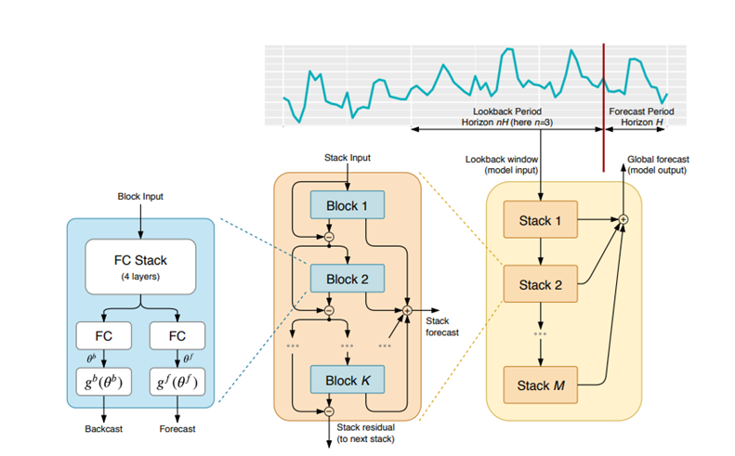

Using the Darts package in Python to implement this N-BEATS architecture, the internal neural network can be trained with multiple time series, or in this case, multiple cyclones. This implementation can also handle multivariate series by flattening components of the series into a one-dimensional series and capturing the interactions between the variables using its fully connected layers (Herzen et al, 2022).

Figure is an example of how the Darts N-BEATS model can fit two training series of length N and length M with a look back window (input) of length 4 and global forecast (output) length 2. Consecutive pairs of input/output of length 4 and 2 respectively, are built and used as training samples for prediction.

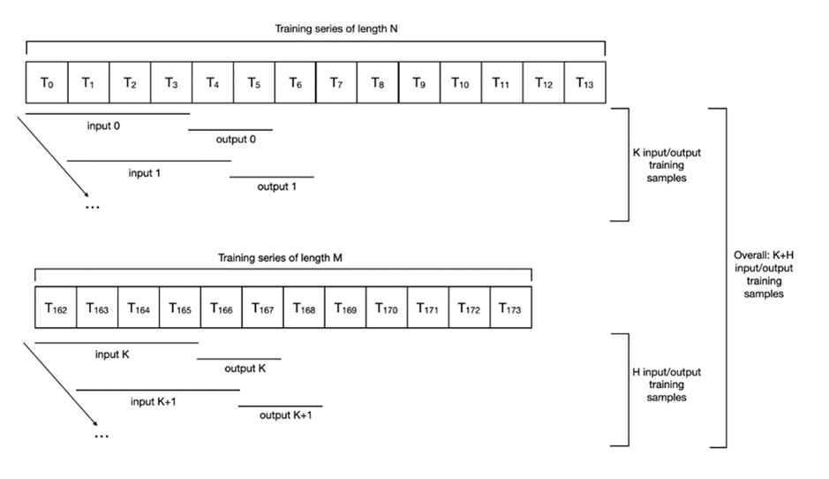

A neural network-based model, once trained, has the advantage of being able to perform forecasts much faster than a numerical model, which requires the entire process to be run for each increment in time (Lam et al 2023). Improvements in computing power have meant that the forecasts from the traditional numerical methods have become more accurate and available at closer time intervals, however the predicting power of these numerical methods still relies on the ability to model the extremely complex global weather by using mathematical equations. An alternative to the traditional numerical weather prediction methods was recently released by Lam et al (2023). Their GraphCast product used a Graph Neural Network to make predictions of the weather across the entire globe. GraphCast was originally trained on the same data that the numerical models were developed to simulate, however, once provided with the data for a given location for two moments in time, being the current time and the moment 6 hours prior, the GraphCast product can then predict the weather for the same location 6 hours into the future. This prediction can then also be used by GraphCast to make further 6 hourly forecasts.

This project used a similar approach to that used by Lam et al (2023) in that it uses a neural network to make predictions about a cyclone’s future behaviour based on the behaviour seen in previous cyclones. The Darts package was used within the Python programming language to build a model that was trained on the data available within BoM’s Tropical Cyclone Best Track database, with variables being selected and filtered as per the recommendations of Courtney and Burton (2018). This model can be trained, tested and output predictions in significantly less time using readily available computing resources. If the accuracy and reliability of such a model can match that of the existing method, significant cost savings could be made.

# Methodology

# Data Description

The data set contained historical information for 1092 cyclones that existed, at least to some degree, within the Australian Area of Responsibility, as defined by Earl-Spurr and Conroy (2024). The data set contained many observation types including pressures, wind speeds, location data and the corresponding date and time. As the aim of this project was to predict the characteristics of cyclones, it was determined that this data set would provide the best training data for a machine learning based model.

## Source of data

The data used in this report was secondary data collected and produced by BoM over many years. It was based on observations made by various methods including ground-based radar, wind and pressure observations, visible, infra-red and microwave satellite imagery as well as observations from ships. The Best Track data was the result of the analysis of available cyclone data to produce a database that can be used for forecasting purposes (Courtney 2022).

## Data Access

Data used in this report was obtained from the BoM website (BoM 2024). The data was readily available, however required a significant amount of cleaning and filtering to make it suitable for modelling with the chosen technique.

The data files obtained were in comma separated values (csv) format.

## Data Description

The descriptions of the data fields from the Best Track database are described in Table 1 below. These descriptions are from BoM (2011), where further details are also available.

Table 1 - Best Track Database Variable Descriptions

|  |  |  |
| --- | --- | --- |
| **Variable** | **Type** | **Description** |
| NAME | String | Cyclone name, “unnamed” if the cyclone was not named |
| DISTURBANCE_ID | String | Unique ID code for reference |
| TM | DateTime | The date/time for this observation, in UTC |
| LAT | Numeric | Latitude of cyclone centre, measured in degrees (decimal) |
| LON | Numeric | Longitude of cyclone centre, measured in degrees (decimal) |
| CENTRAL_PRES | Numeric | Central pressure of cyclone, measured in hectopascals (hPa) |
| ENV_PRES | Numeric | Environmental pressure in which cyclone is embedded, measured in hectopascals (hPa) |
| MN_RADIUS_GF_SECNE | Numeric | Mean radius from the cyclone centre to distance of gale-force winds (34 kn) in the Northeast quadrant, measured in km |
| MN_RADIUS_GF_SECSE | Numeric | Mean radius from the cyclone centre to distance of gale-force winds (34 kn) in the Southeast quadrant, measured in km |
| MN_RADIUS_GF_SECSW | Numeric | Mean radius from the cyclone centre to distance of gale-force winds (34 kn) in the Southwest quadrant, measured in km |
| MN_RADIUS_GF_SECNW | Numeric | Mean radius from the cyclone centre to distance of gale-force winds (34 kn) in the Northwest quadrant, measured in km |

# Methodology

## Methodologies

This project was implemented in Python programming and had 4 main stages: data pre-processing, descriptive analysis, data modelling and evaluation and data visualisation.

1. **Data pre-processing:**

Following data cleaning tasks were conducted in preparing the data for analysis and modelling:

• Identifying and handling data quality issues: the data set was inspected for any incorrect data structures, misspelling or trailing white spaces and corrected as necessary.

• Handling Outliers: to be discussed in the descriptive analysis.

• Data resampling to 6-hourly interval: Resampling observations of each cyclone based on its ‘DISTURBANCE_ID’ and ‘TM’ so that all cyclones have a uniform format of 6-hourly interval observations.

• Missing values: grouped by each cyclone using ‘DISTURBANCE_ID’, various techniques for handling missing values were adopted in different steps of the data cleaning process. For numerical features, where appropriate, linear interpolation was used to fill missing values between any two valid data points within one column and k-nearest neighbour imputation was used to fill the rows with only 1 missing value using its 3 nearest neighbours in the data set. For categorical variables (name and ID), forward filling was used to propagate the last valid observation to next valid.

• Finally, each cyclone will be converted into a separate multivariate time series in preparation for modelling.

1. **Descriptive analysis:**

Descriptive analysis included producing statistical summaries and box plots for each selected variable. This analysis was used to identify potential outliers. Extreme values do not always indicate a problem with the data but could in fact be associated with particularly strong cyclones. This analysis was also used to investigate the reasoning behind the selection of variables as recommended by Courtney and Burton (2018) who recommended omitting observations where the gale force wind radii were above 300 km due to as these wind speeds being more likely associated with the surrounding environment than the cyclone itself.

1. **Data modelling and evaluation:**

In this project, we are only interested in studying the cyclones that lasted at least 72 hours. Hence, after cleaning stage, we selected those cyclones with minimum of 12 observations for modelling. As a result, 94 cyclones were selected. *The process of data modelling and evaluation for this research paper can be described as follows:*

The 94 cyclones were split into training set and test set with ratio of 93 cyclones: 1 cyclone respectively. The model was trained on training set and was test and validated on test set. Each component of every cyclone was scaled between 0 and 1 before being used for model training or validation.

At model fitting step, by fitting 93 training cyclones to the NBEATS, the model would flatten these multiple multivariate series into a univariate time series and trained the neural network using consecutive pairs of [input chunk length of 6 observations/ output chunk length of 4 observations] training samples. The number of training samples depending on the length of all training cyclones. As there was 6-hour gap between observations, this means the model would learn the pattern of target series in the next 24 hours by looking back the window of 36 hours.

The validating cyclone was then used for testing the fitted model and making predictions for 8 observations (48 hours). Because the output chunk length (4) was smaller than the length of prediction horizon (8), after predicting the first 4 points, the model used these 4 outputs to feed the model and made the predictions for the next 4 points auto-regressively. At the end of the process, the NBEATS model reshaped the forecasts from univariate series to a tensor of appropriate dimensions or so-called corresponding variables. These forecasts can be in scaled format or can be converted to each component’s original metric units by inverse-scaling depending on the research purpose.

For model evaluation, multiple model evaluation metrics including Mean Absolute Error (MAE), Root Mean Squared Error (RMSE) and Mean Squared Error (MSE) were calculated. The lower the errors, the better a model performed.

Our model evaluation strategy was to conduct cross-validation using back test to minimise the chance of lucky split. The process of back testing was similar to how the model was trained. The testing cyclone was folded into multiple consecutive pairs of [input chunk length of 6 observations/prediction horizon of 8 observations] testing samples. In other words, 48-hour predictions were made with look back window of 36 hours. The number of testing samples depended on the length of the testing cyclone. For every testing sample, at each forecast point (from 1 to 8), errors were calculated between the actual value and the predicted value. The mean of errors at each forecast points across all testing samples were used to evaluate model performance.

To answer the first research question, we repeated model training process 4 times, each time the model was tested using one of following 4 cyclones: Lucas, Marian, Seroja and Niran. To study cyclone path prediction accuracy, first, only longitude and latitude were fitted to the model for prediction. Next, we explored the difference between actual path and predicted path by plotting these tracks on a world map. In a step further, the report compared project’s forecasts and BoM’s forecasts (ref: verification report) on the predicting errors of each coordinate component produced by each approach. On the other hand, the predicting errors of a model fitted with only Mean radius of gale force winds (R34s) of all 4 quadrants were also calculated to investigate the accuracy of model prediction for cyclone intensity.

For the second research question, regarding cyclone path, the research developed 4 models with 2 target series of Longitude and Latitude. Each of these 4 models was then fitted with different sets of past covariates including (0) no covariates, (1) pressures as covariates, (2) R34s as covariates and (3) both pressures and R34s as covariates. In a paired fashion (same random state and random seed) and leave-one-out method, each model was trained with 93 cyclones and tested on 1 cyclone using back test as discussed above and the process was repeated 4 times, each time 1 cyclone was left out and the model was retrained with the rest of 93 cyclones. Next, we compared the performance of the model without covariates with each of other 3 models using paired t-test to check the statistical difference in the mean values of their predicting errors at 95% confident intervals. The sample size was 43 back test sets (43 testing samples). Finally, the best model was selected based on the result of paired t-test and Parsimony principles (i.e. the simplest model with fewest entities). A similar approach was implemented for studying the best set of features for predicting cyclone intensity, except that this was based on 4 models with 4 target series of R34s of all 4 quadrants and sets of past covariates including (0) no covariates, (1) pressures as covariates, (2) coordinates as covariates, (3) both pressures and coordinates as covariates.

The hypothesis for each paired t-test in Research Question 2:

H0: The true mean difference is equal to zero. There is no significant difference in predicting errors between the two models.

H1: The true mean difference is not equal to zero. There is significant difference in predicting errors between the two models.

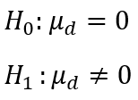

To investigate the third research question, in studying cyclone path, we again fitted the NBEATS model with 2 target series of Longitude and Latitude. The model was also trained on 93 cyclones and tested on 1 cyclone using back test. However, in this section, we classified the cyclones used for validation into East and West regions. To understand the model performance for predicting cyclone path in East regions, we used leave-one-out method as described in second research question methodology to repeat the training/cross-validation process 24 times, each time with different cyclones in East region. Similarly, we repeated the process 25 times, each time with different cyclones in West region to study the model performance for predicting West region cyclones. The purpose of this design was to enable two independent samples t-tests to check the statistical difference between the mean values of predicting errors in both regions. Firstly, we conducted two independent sample t-test in terms of predicting errors of 24 cyclones (sample size of 24 cyclones) randomly selected from each region. Secondly, we conducted two independent sample t-test in terms of predicting errors of 218 back test sets/samples (sample size of 218 testing samples) randomly selected from each region. Before every two independent samples t-test, we performed Fligner-Killeen test for equality of variance to check for equal variance assumption. In case equal variance could not be assumed, Welch’s t-test was used instead. A similar approach was used to study model performance for predicting cyclone intensity in each region, the only difference was that instead of Longitude and Latitude, we fitted the NBEATS model with R34s of all 4 quadrants.

The hypothesis for each two independent samples t-test in Research Question 3:

H0: In the population, average predicting errors do not differ significantly between East region and West region.)

H1: In the population, there is significant difference between the predicting errors between East region and West region.)

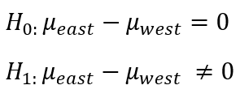

1. **Data visualisation**

The predicted cyclone paths generated were compared with the actual paths visually using the geopandas and movingpandas libraries in a method similar to that described by Tenkanen (2024). This not only allowed for the predicted and actual paths to be compared easily, but since it also overlays the paths on a map of the Australian region, differences between the model’s performance in different Australian sub-regions were also visible.

## Practical Issues

The more data per cyclone that can be used for training a model, the better the model is expected to perform. Reducing the number of observations per cyclone used for training will make more cyclones available, it may be at the cost of data quality. While missing data can be interpolated to make cyclone data suitable for model training, it was decided not to extrapolate data before or after the available data because this is normally associated with a cyclone that is still forming or is degrading. Alternatively, including more observations per cyclone will necessitate filtering out some cyclones from the training set.

As deep learning models work best with large amounts of training data, to maximise the amount of data available to the model, only a single cyclone is to be used for validation at a time. This means that the model needs to be trained for each individual cyclone to be validated, which involves significant processing time.

The different behaviours of cyclones between the NE and NW regions may also impact the model’s performance, as such, it may be beneficial to split the data before training to improve its performance. The sea surface temperatures in the Indian Ocean are observed to be more homogenous that those observed in the Coral Sea. Currently BoM uses different numerical models for cyclones depending on which region they are in to account for this.

# Results

## Research Question 1

To determine the accuracy of the deep learning model in predicting the path of cyclones, the errors in the predictions of latitude and longitude for four cyclones were calculated. Only latitude and longitude data were included in the training dataset. The errors for cyclones Lucas, Marian, Niran and Seroja are shown in figure xx below. The errors shown are a combination of errors in latitude and longitude and are scaled between zero and one.

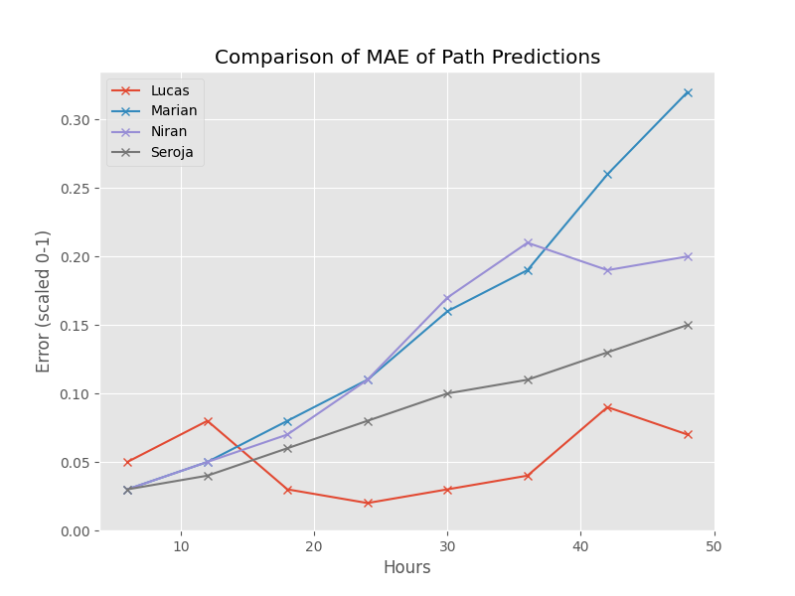The actual paths of these four cyclones, along with the final 48 hours as predicted by the model, were plotted on a map in figure xx below. These paths generally showed more accurate predictions of cyclone paths in the Coral Sea versus those in the Indian Ocean.

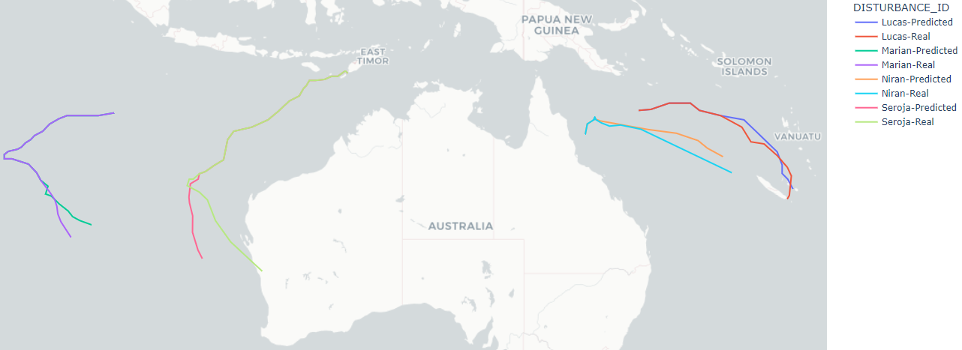

To compare the model’s prediction error to that of BoM’s model, the unscaled error for predictions of latitude and longitude, measured in nautical miles, were each calculated and plotted. Figure xx below, shows that in the case of cyclone Lucas, the model was both more accurate and less accurate than the BoM model at different forecast times. This figure also shows that the model can sometimes produce a more accurate prediction further into the future than at closer prediction points, whilst for the most part, the errors in the BoM model’s predictions tend to steadily increase as the prediction time increases.

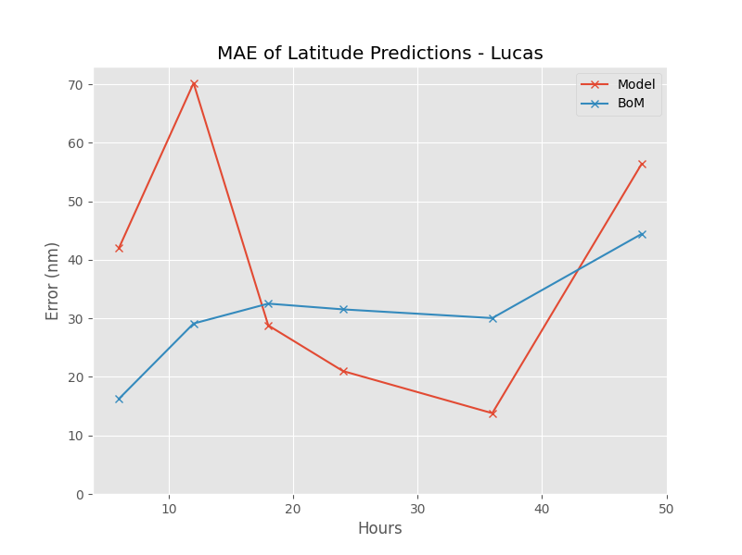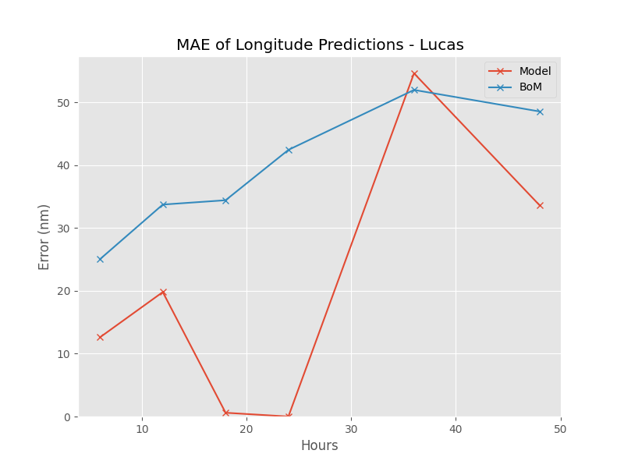In the case of cyclone Marian, figure xx below shows the model’s error increasing at a much faster rate than that of BoM’s model.

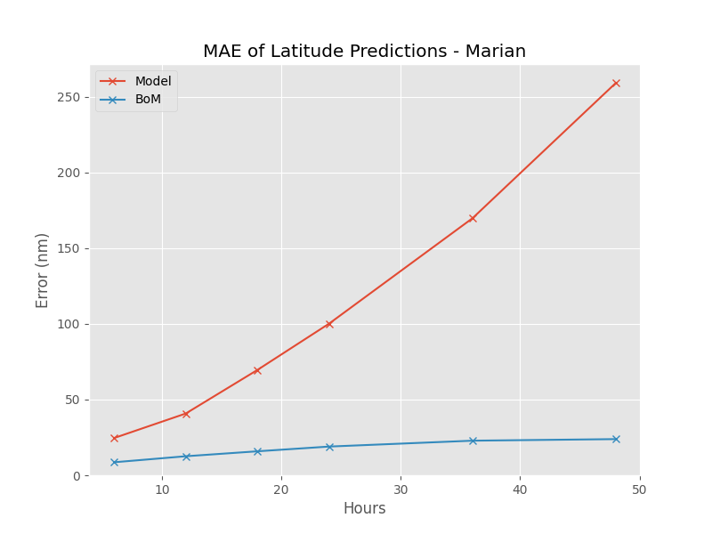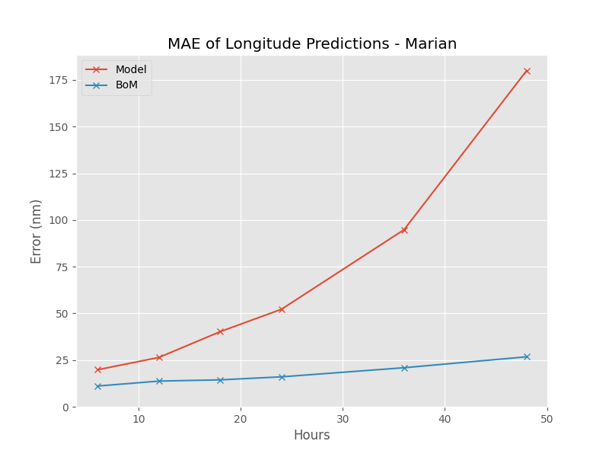Figure xx below, shows the model performing better than BoM’s model for most prediction points for latitude but worse for longitude. Again, the model showed an ability to make improved predictions at more distant prediction times.

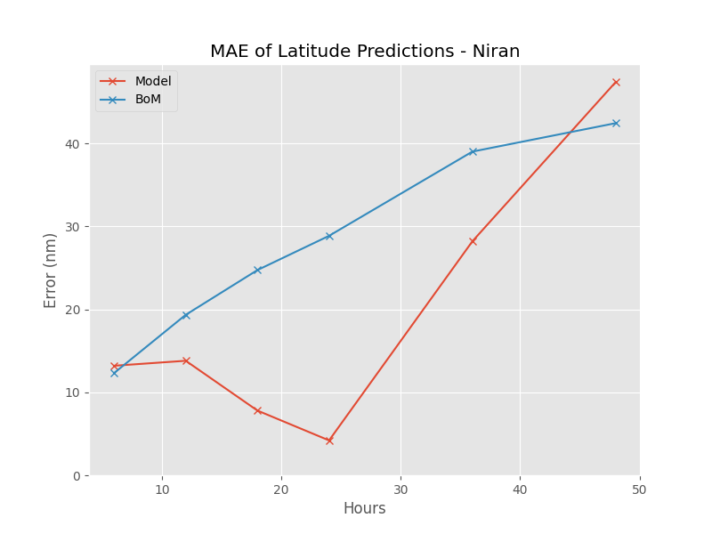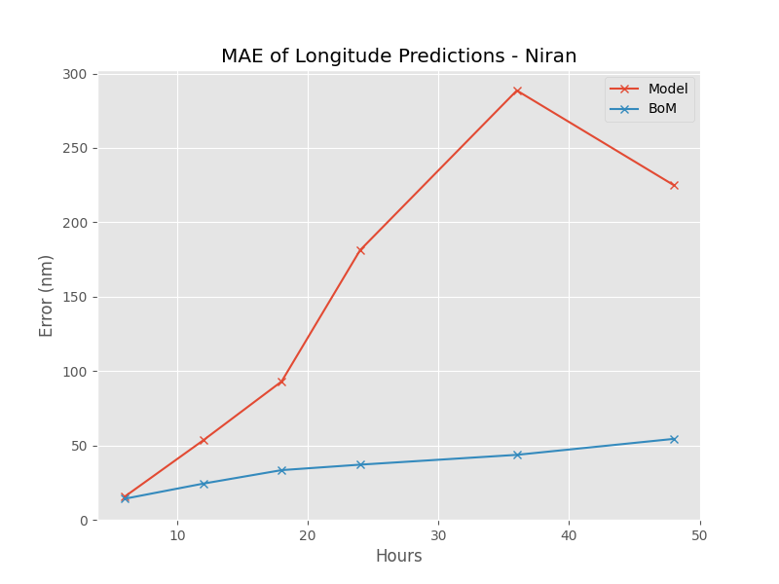In the case of cyclone Seroja, figure xx below shows the model’s error increasing at a faster rate than that of BoM’s model.

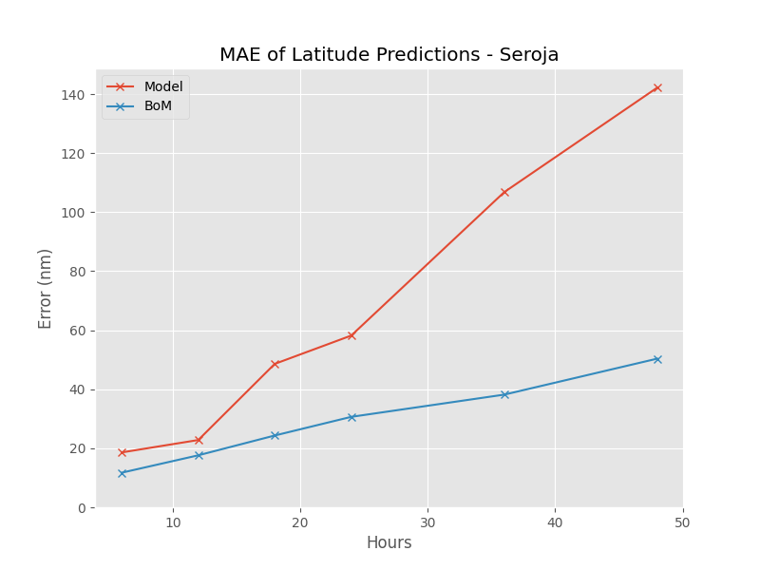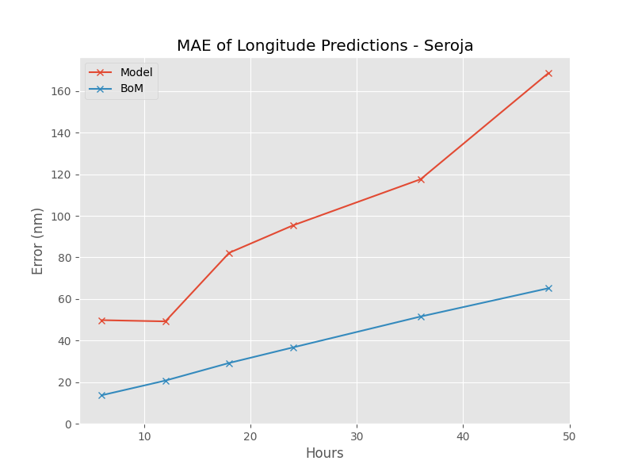

To determine the accuracy of the model in determining cyclone intensity, as measured by R34 distance, the errors in the predictions of the R34 distance in each quadrant were calculated for the same four cyclones. Only R34 distances were used for training the model. The errors for these cyclones is shown in figures xx to xx below.

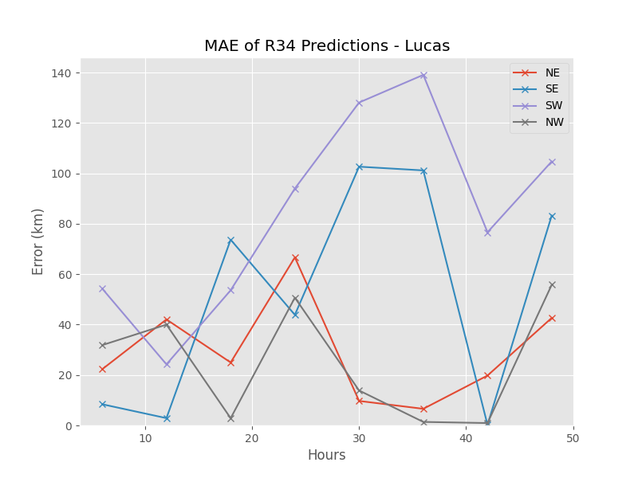

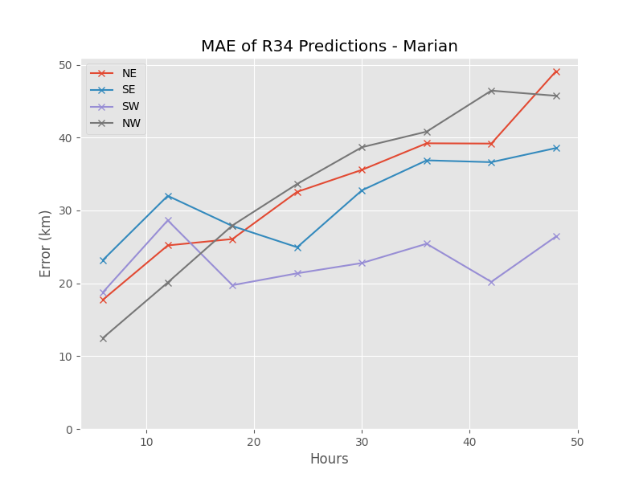

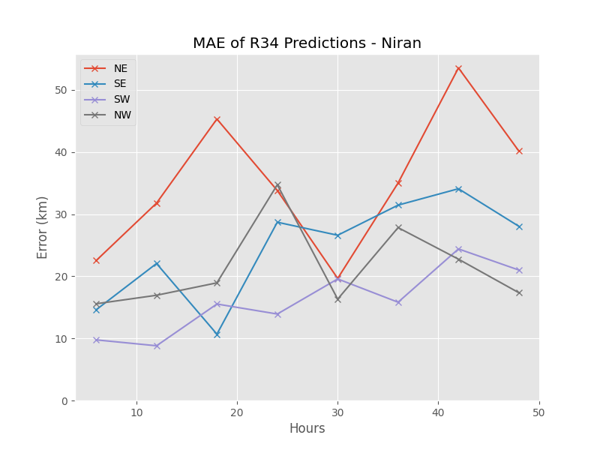

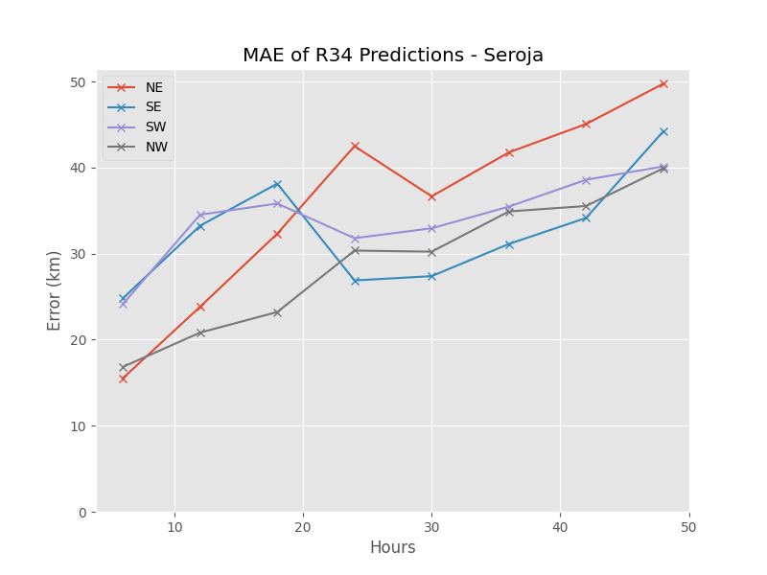

1. Results of Research Question 2

2.1 Cyclone Path

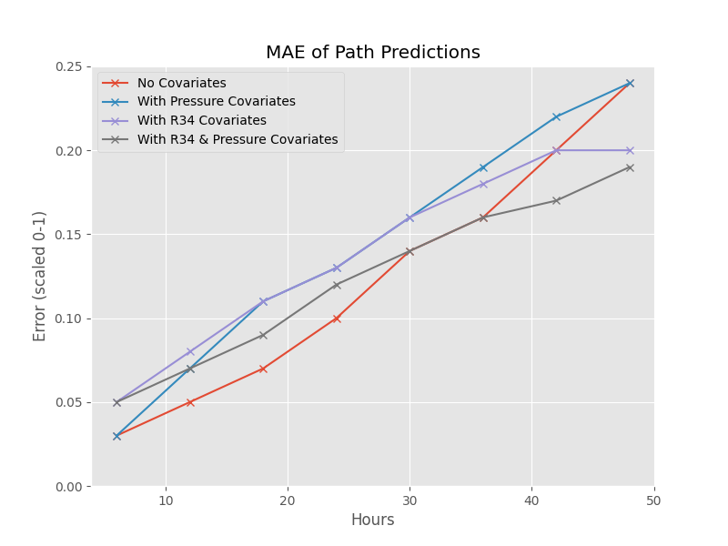From Figure , we can see that in general, among the 4 assessed models, the model without covariates had the lowest MAE values of scaled data at 6h, 12h, 18h, 24h, 30h forecast points, which were 0.03, 0.05, 0.07, 0.1 and 0.14 respectively. However, the MAE of no covariates model took over other models at 36h forward with values of 0.16, 0.2 and 0.24 at 36h, 42h, and 48h respectively.

From Figure , Table of Mean of Error Scores showed that across 8 forecast points, no covariate model gave the lowest MAE of 0.1216, the second lowest RMSE of 0.1462 and the second lowest MSE of 0.0309. Meanwhile, the model with full set of covariates gave second lowest MAE of 0.1246 and the lowest RMSE of 0.1423 and the lowest MSE of 0.0282.

The Figure also showed the outputs of all pair t-tests between models in terms of MAE, RMSE and MSE at 95% confident interval. There was significant difference between MAE of no covariate model and model with pressures as covariates. This means no covariate model statistically gave lower predicting error values than model with pressures as covariate features in terms of MAE.

Other paired t-test results showed that the mean difference in predicting errors between two models can be assumed to be equal to zero, meaning there is no statistically significant difference in the performance of no covariate model comparing to other models with covariates in terms of MAE, RMSE and MSE across 8 forecast points at 95% confident interval (p-values were greater than 0.05).

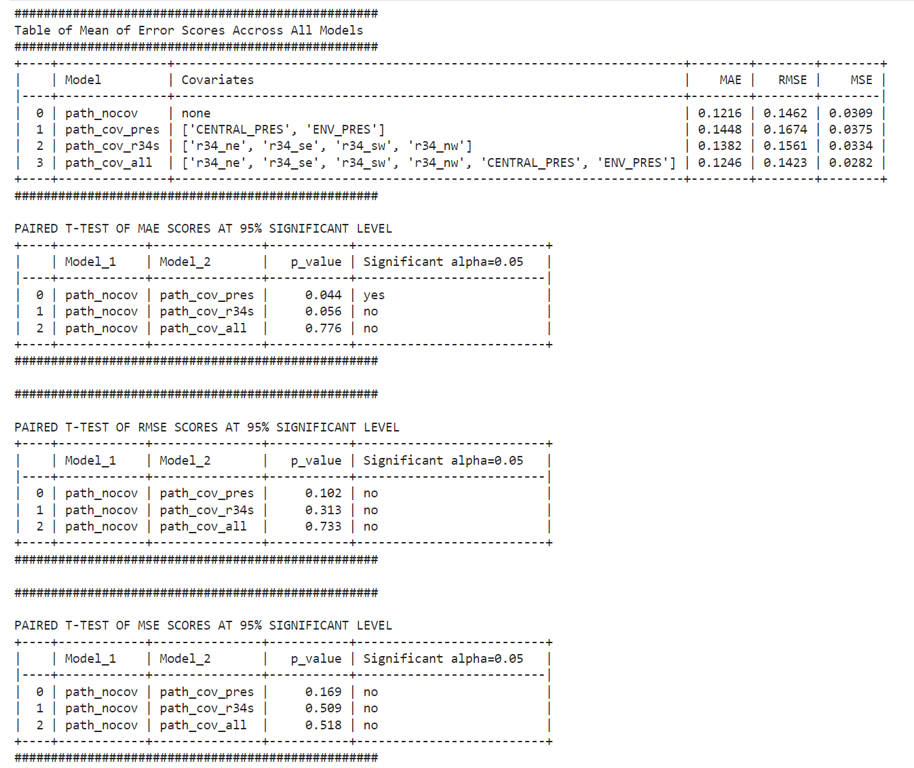

2.2 Cyclone Intensity

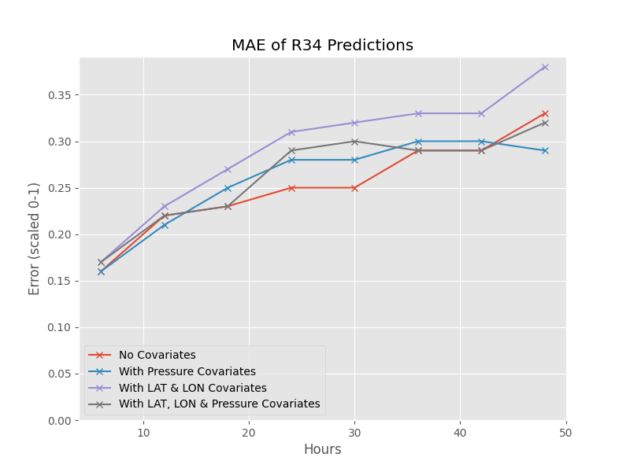

From Figure , in general, no covariate model gave the lowest MAE at most forecast points with values of 0.16, 0.22, 0.23, 0.25, 0.25, 0.29, 0.29 and 0.33 at 6h, 12h, 18h, 24h, 30h, 36h, 42h and 48h respectively.

From Figure , Table of Mean of Error Scores showed that across 8 forecast points, no covariate model gave the lowest MAE of 0.2528, the lowest RMSE of 0.2957 and the second lowest MSE of 0.1025. Meanwhile, the model with pressures as covariates gave the second lowest MAE of 0.2585, the second lowest RMSE and the lowest MSE.

Investigating the paired t-test results from Figure , we can see that there was significant difference in the mean errors of no covariate model and model with coordinates (path) as covariates. This means at 95% confident intervals, no covariates model statistically gave lower values of MAE, RMSE and MSE than model with coordinates as covariate features (p-values were smaller than 0.05).

Other paired t-test results showed that the mean difference in predicting errors between two models could be assumed to be equal to zero, meaning there was no statistically significant difference in the performance of no covariate model comparing to model with pressures as covariates and model with full set of covariates in terms of MAE, RMSE and MSE across 8 forecast points at 95% confident interval (p-values were greater than 0.05).

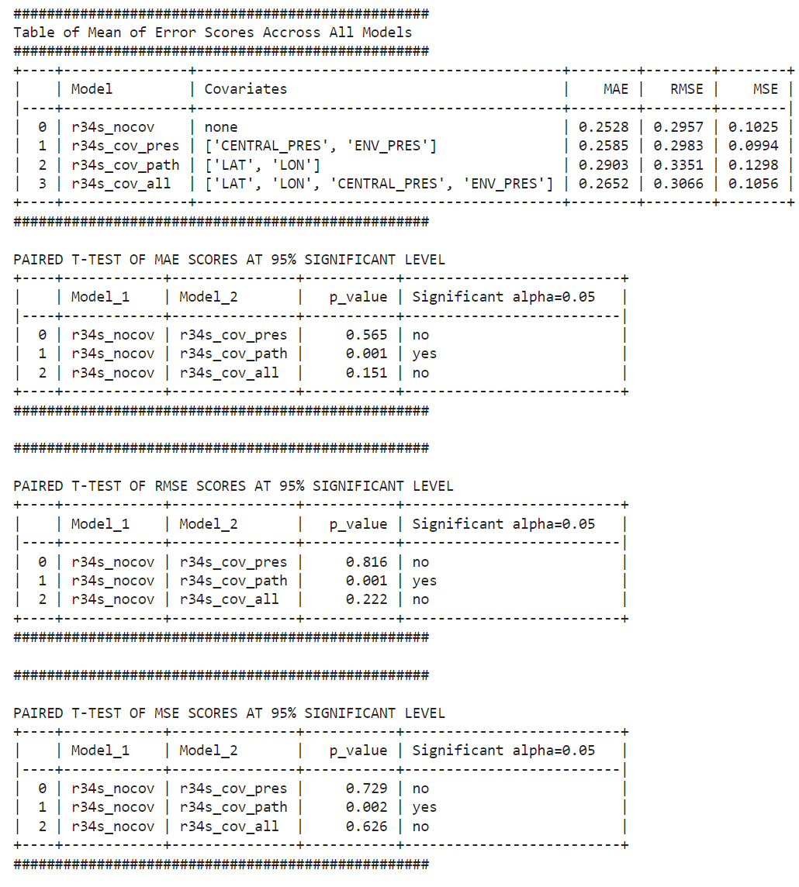

3. Results of Research Question 3

3.1 Cyclone Path

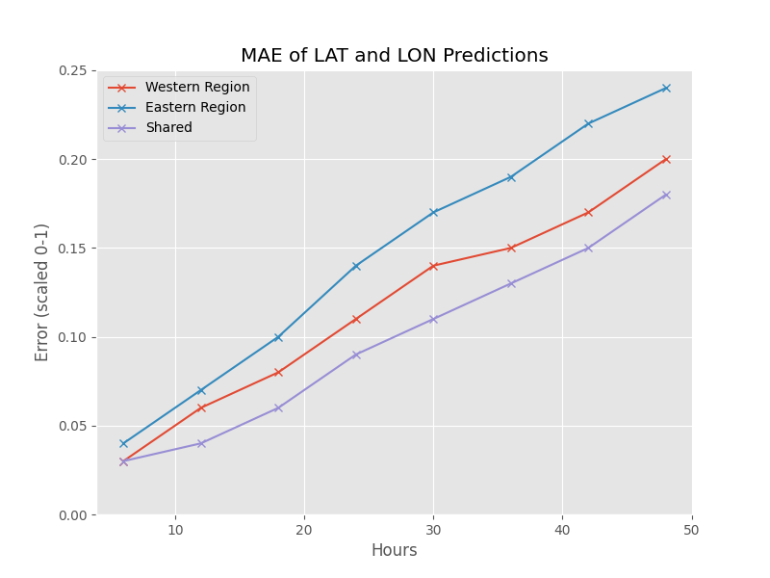

Figure [] showed that across all 8 forecast points, the fitted NBEATS model generally gave the lowest MAE scores for those cyclones in shared zone, followed by those cyclones in Western region, and gave the highest MAE scores for those cyclones in Eastern region.

For those cyclones in shared zone, the MAE values were 0.03, 0.09 and 0.18 at 6h, 24h and 48h respectively. Meanwhile, the cyclones in Western area saw slightly higher MAE values of 0.03, 0.1 and 0.19 at 6h, 24h and 48h respectively. The MAE values of the cyclones in Eastern regions were 0.04, 0.14 and 0.24 at 6h, 24h and 48h respectively.

The Table of Mean of Error Scores in Figure [] showed that when validating the fitted NBEATS model with 24 eastern cyclones, the model gave higher predicting errors in terms of MAE, RMSE and MSE compared to when validating with 24 western cyclones.

From Figure [], the results from Fligner-Killeen tests for equality of variance confirmed that equal variance could be assumed when assessing MAE, RMSE and MSE for two independent samples t-test. The outputs from these t-tests confirmed that at 95% significant level, there was no statistically significant difference in NBEATS predicting errors for cyclones from Eastern regions and cyclones from Western regions in terms of MAE, RMSE and MSE (all p-values were greater than 0.05).

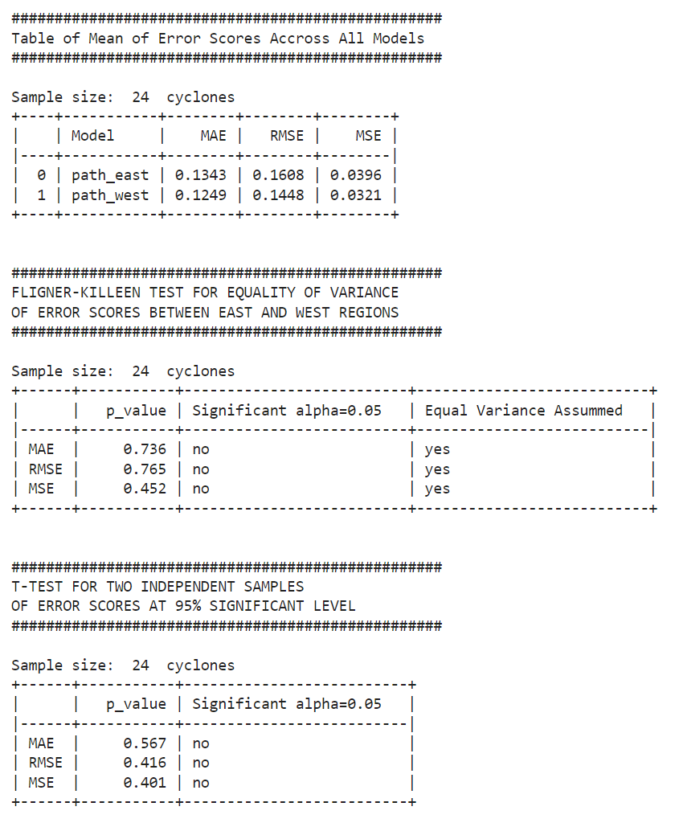

The Table of Mean of Error Scores in Figure [] showed that when validating the fitted NBEATS model with 218 back test samples of the cyclones from Eastern region, the model gave higher predicting error scores in terms of MAE, RMSE and MSE compared to when validating with 218 back test samples of the cyclones from Western region.

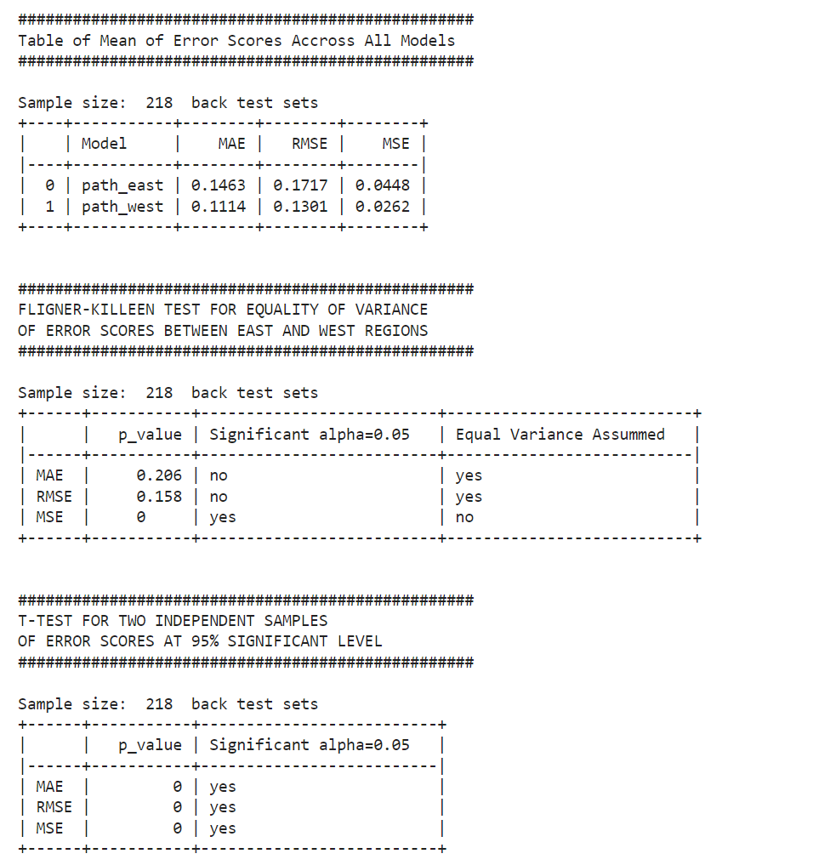

From Figure [], the results from Fligner-Killeen tests for equality of variance confirmed that equal variance could be assumed when assessing MAE and RMSE and could not be assumed when assessing MSE for two independent samples t-test. The outputs from these t-tests confirmed that at 95% significant level, there were statistically significant difference in predicting errors of back test samples for cyclones from Eastern regions and for cyclones from Western regions in terms of MAE, RMSE and MSE (all p-value were very close to 0).

3.2 Cyclone Intensity

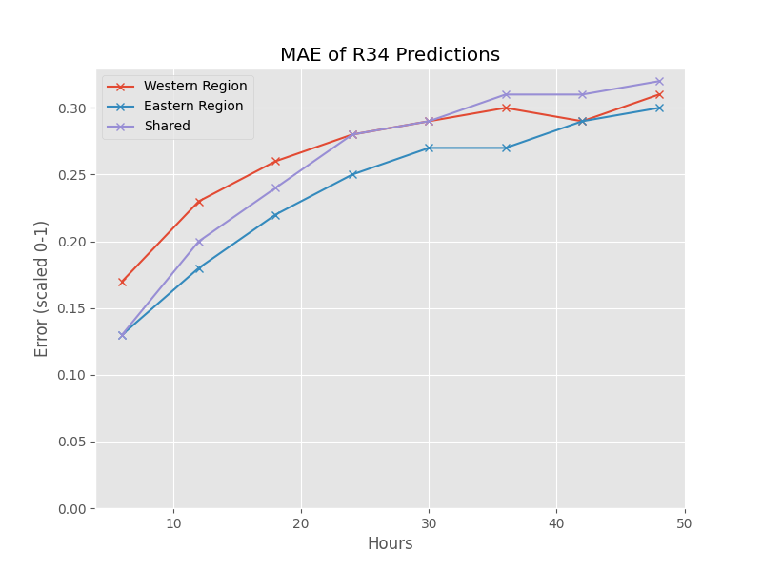Figure [] showed that generally across 8 forecast points, the NBEATS model gave the lowest MAE of 0.13, 0.25 and 0.3 at 6h, 24h and 48h forecast points respectively when being validated with cyclones from Eastern region. Meanwhile, the MAE for predicting cyclones from Western region were 0.17, 0.28 and 0.31 at 6h, 24h and 48h forecast points respectively.

The Table of Mean of Error Scores in Figure [] showed that when validating the fitted NBEATS model with 24 eastern cyclones, the model gave lower predicting errors in terms of MAE, RMSE and MSE compared to when validating with 24 western cyclones.

From Figure [], the results from Fligner-Killeen tests for equality of variance confirmed that equal variance could be assumed when assessing MAE, RMSE and MSE for two independent samples t-test. The outputs from these t-tests confirmed that at 95% significant level, there was no statistically significant difference in NBEATS predicting errors for cyclones from Eastern regions and cyclones from Western regions in terms of MAE, RMSE and MSE (all p-values were greater than 0.05).

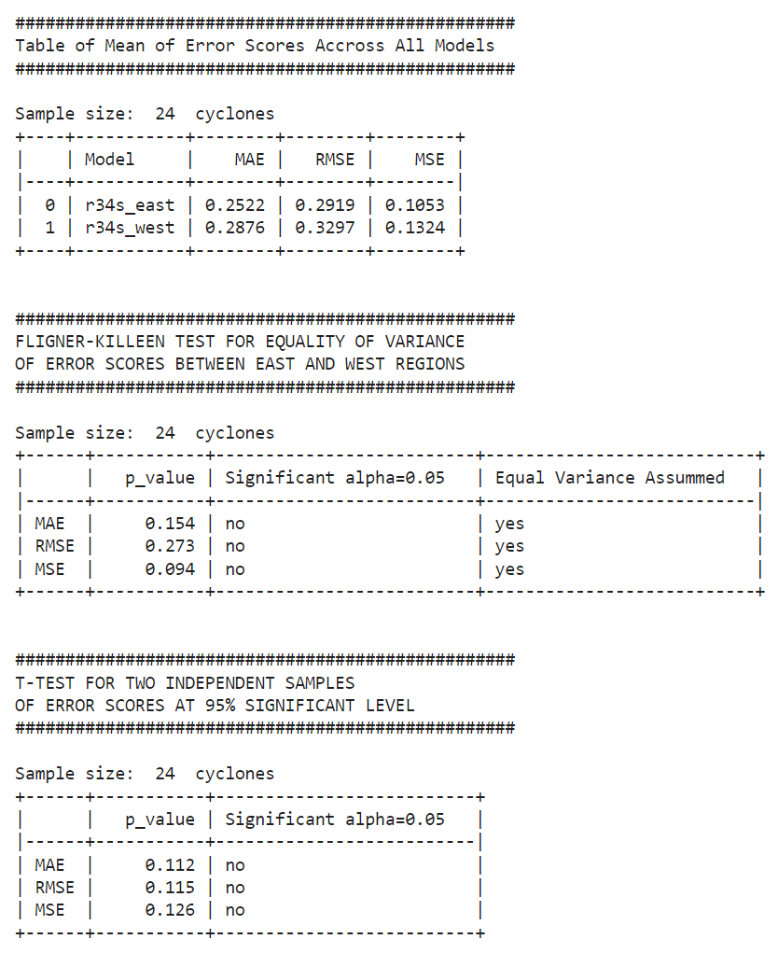

The Table of Mean of Error Scores in Figure [] showed that when validating the fitted NBEATS model with 218 back test samples of the cyclones from Eastern region, the model gave higher predicting error scores in terms of MAE, RMSE and MSE compared to when validating with 218 back test samples of the cyclones from Western region.

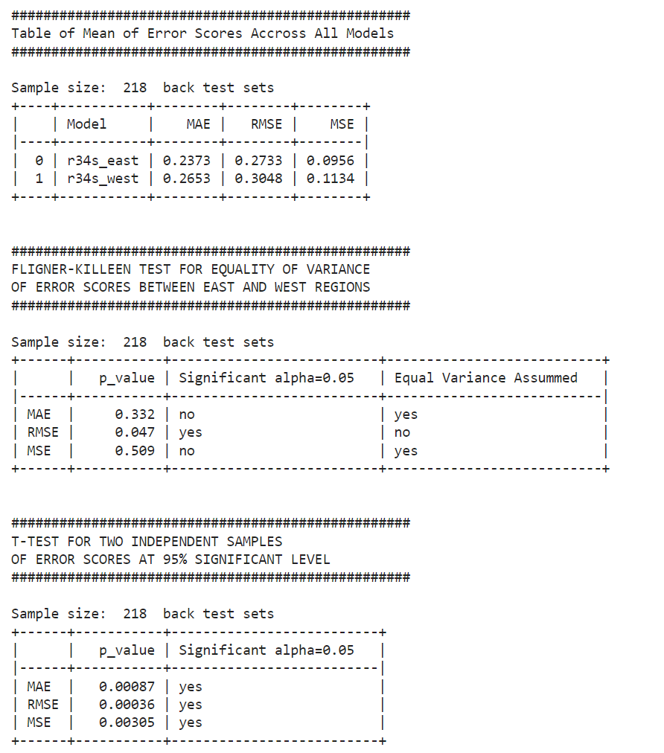

From Figure [], the results from Fligner-Killeen tests for equality of variance confirmed that equal variance could be assumed when assessing MAE and MSE and could not be assumed when assessing RMSE for two independent samples t-test. The outputs from these t-tests confirmed that at 95% significant level, there were statistically significant difference in predicting errors of back test samples for cyclones from Eastern regions and for cyclones from Western regions in terms of MAE, RMSE and MSE (all p-value were very close to 0).

# Discussion

1. Research Question 1
2. Research Question 2

2.1 Cyclone Path

1. Research Question 3
2. Summary of Findings

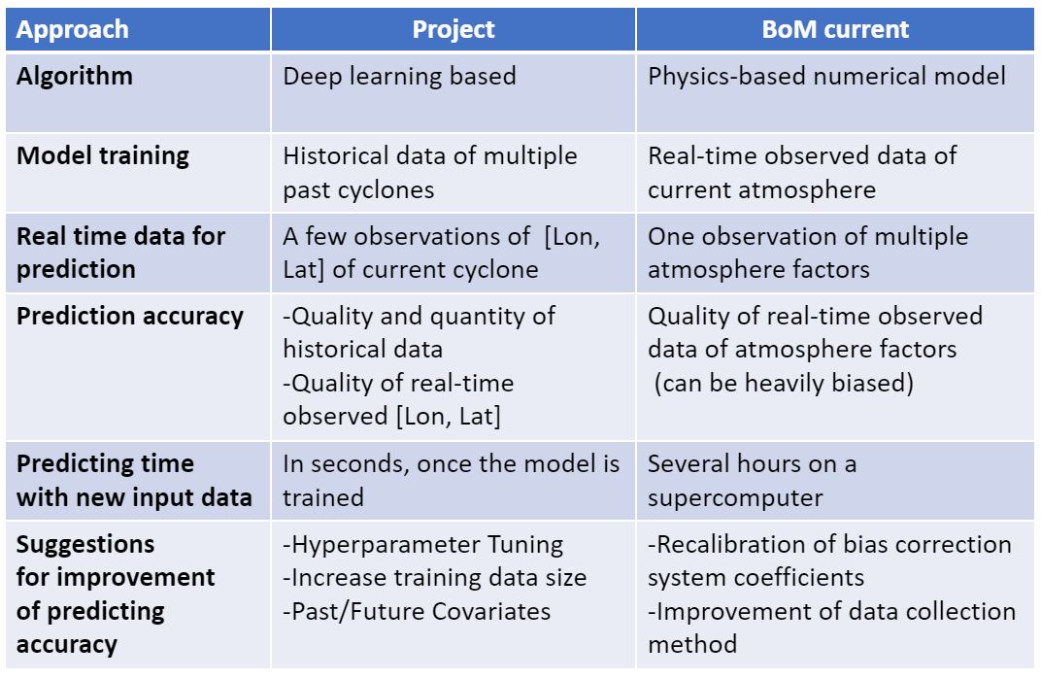

# Conclusion

Text.

# Students’ Contributions

Text.

# References

ACS (Australia Climate Service) (2024) *Tropical cyclones,* BoM website, accessed 16 April 2024. <https://www.acs.gov.au/pages/91d87853778847e5914c59b60ea8bd53>

BoM (Bureau of Meteorology) (2024a) *Tropical cyclone knowledge centre*, BoM website, accessed 13 April 2024. <http://www.bom.gov.au/cyclone/tropical-cyclone-knowledge-centre/>

BoM (Bureau of Meteorology) (2024b) *Predicting tropical cyclones*, BoM website, accessed 15 April 2024. <http://www.bom.gov.au/cyclone/tropical-cyclone-knowledge-centre/predicting-cyclone/>

BoM (Bureau of Meteorology) (2024c) *Tropical cyclone reports*, BoM website, accessed 14 April 2024. <http://www.bom.gov.au/cyclone/tropical-cyclone-knowledge-centre/history/past-tropical-cyclones/>

Chen Y, Kepert J D, Aijaz S and Ye H (2019) *Recalibration of coefficients for the ECMWF-Ensemble Prediction System Bias Correction model*, Bureau of Meteorology, Australian Government, personal communication received 18 March 2024.

Courtney J (2022) *A Guide for Best Tracking Tropical Cyclones in the Australian Region,* Bureau of Meteorology, Australian Government, personal communication received 18 March 2024.

Courtney J and Burton A (2018) *Joint Industry Project for Objective Tropical Cyclone Reanalysis: Final Report*, BoM website, accessed 25 March 2024. <http://www.bom.gov.au/cyclone/tropical-cyclone-knowledge-centre/databases/>

Earl-Spurr C and Conroy A (2024) *Tropical Cyclone Service Level Specification,* Bureau of Meteorology, Australian Government, personal communication received 23 April 2024.

Herzen J, Lässig F, Piazzetta S G, Neuer T, Tafti L, Raille G, Van Pottelbergh T, Pasieka M, Skrodzki A, Huguenin N, Dumonal M, Kościsz J, Bader D, Gusset F, Benheddi M, Williamson C, Kosinski M, Petrik M and Gaël Grosch (2022) ‘Darts: User-Friendly Modern Machine Learning for Time Series’, *Journal of Machine Learning Research*, 23(124):1−6, JMLR website, accessed 8 April 2024. <https://www.jmlr.org/papers/v23/21-1177.html>

Lam R, Sanchez-Gonzalez A, Willson M, Wirnsberger P, Fortunato M, Alet F, Ravuri S, Ewalds T, Eaton-Rosen Z, Hu W, Merose A, Hoyer S, Holland G, Vinyals O, Stott J, Pritzel A, Mohamed S and Battaglia P (2023) ‘Learning skillful medium-range global weather forecasting’, *Science*, 382(6677):1416-1421, doi: 10.1126/science.adi2336

Oreshkin B N, Carpov D, Chapados N, Bengio Y (2020) *N-BEATS: Neural basis expansion analysis for interpretable time series forecasting*, arXiv e-prints, accessed 9 May 2024. <https://doi.org/10.48550/arXiv.1905.10437>

Paterson L (2019) *Severe Tropical Cyclone Veronica*, Bureau of Meteorology website, accessed 25 March 2024. <http://www.bom.gov.au/cyclone/history/veronica.shtml>

Tenkanen H (2024) *Tutorial 4: Trajectory data mining in Python*, Spatial Data Science for Sustainable Development website, accessed 1 April 2024. <https://sustainability-gis.readthedocs.io/en/latest/lessons/L5/mobility-analytics.html>

Watkins A (2022) *Pre Tropical Cyclone Season Briefing 2022/23*, Bureau of Meteorology, Australian Government, personal communication received 18 March 2024.

# Appendix A

Figure 1 shows…

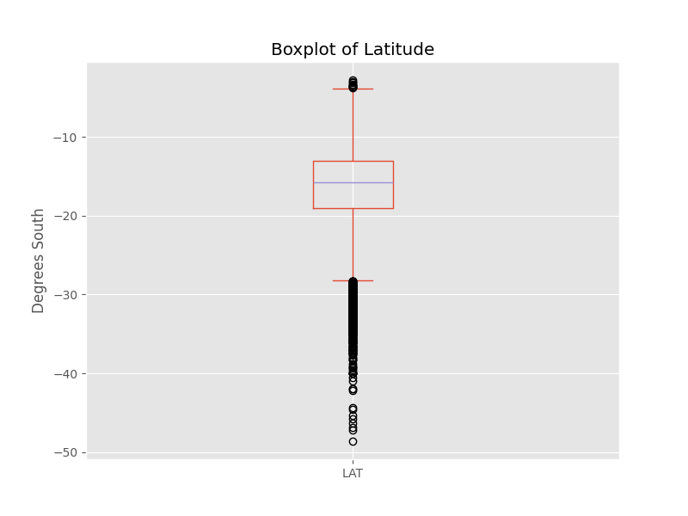

Figure 1 - Box Plot of the Latitude of all cyclones in the BoM data set

Figure 2 shows…

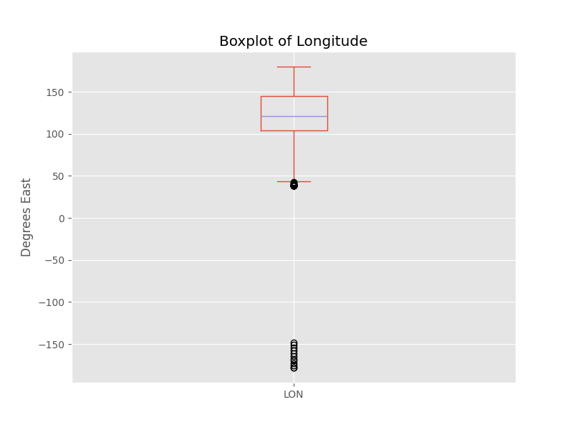

Figure 2 - Box Plot of the Longitude of all cyclones in the BoM data set before cleaning

Figure 3 shows…

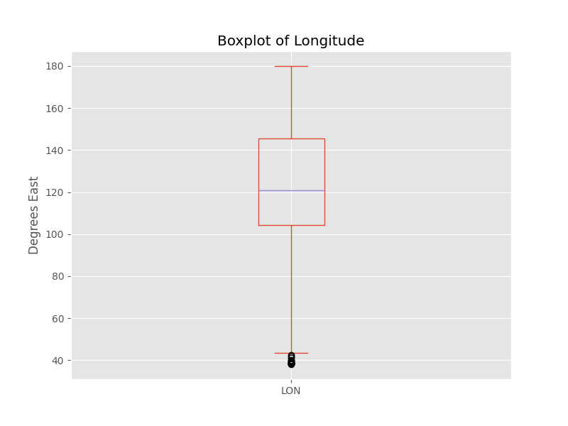

Figure 3 - Box Plot of the Longitude of all cyclones in the BoM data set after cleaning

Figure 4 shows…

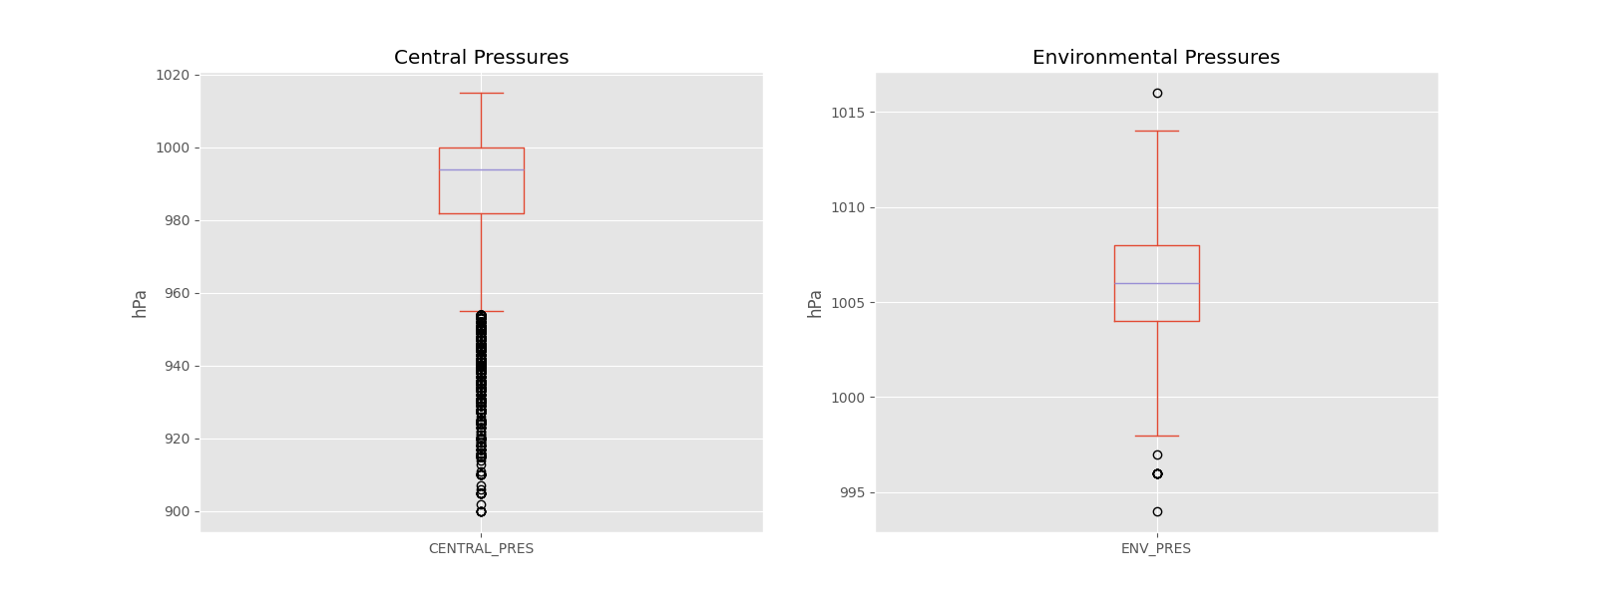

Figure 4 - Box Plots of the Central & Environmental Pressures of all cyclones in the BoM data set

Figure 5 shows…

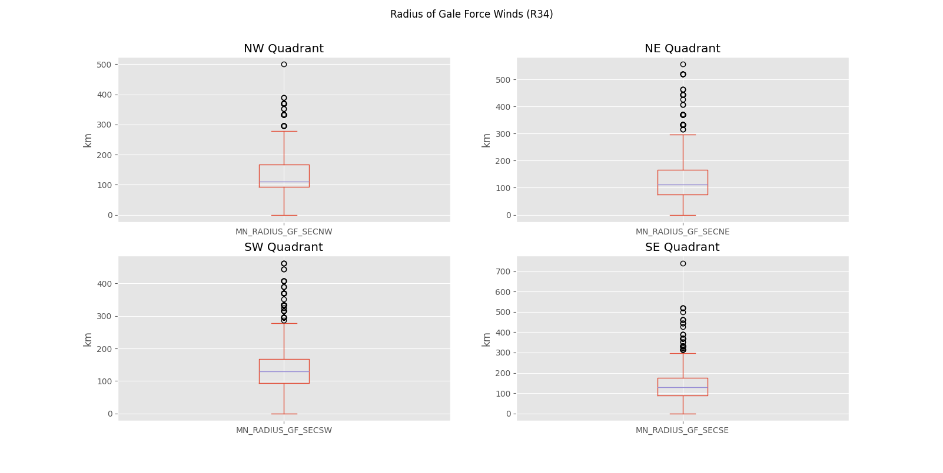

Figure 5 - Box Plots of the R34 Wind Radii of all cyclones in the BoM data set

Figure 6 shows…

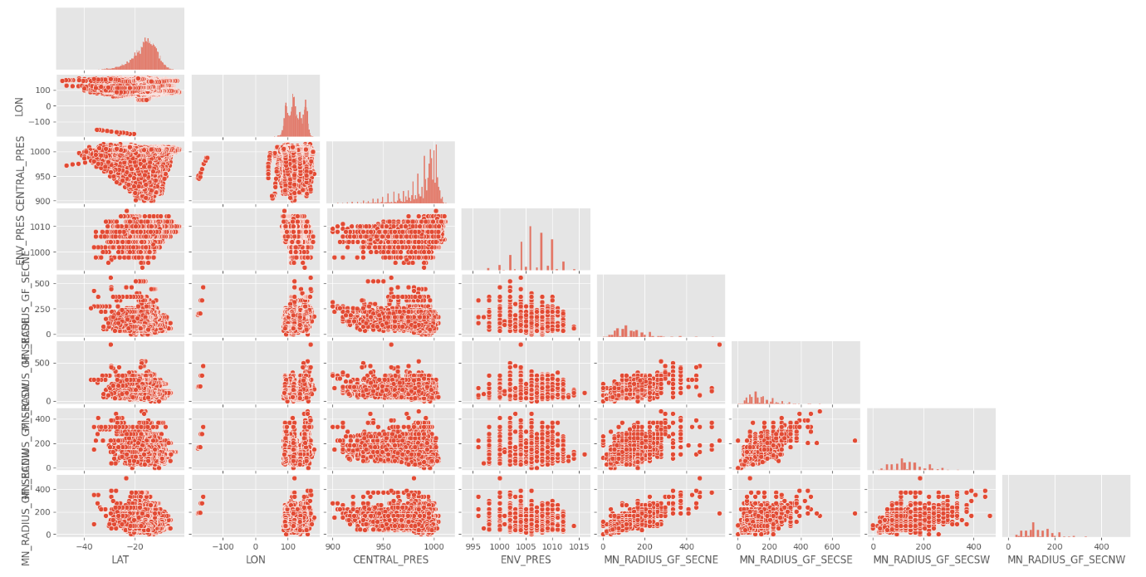

Figure 6 - Scatter Plots of all variables for all cyclones used in modelling before cleaning Longitude data

Figure 7 shows…

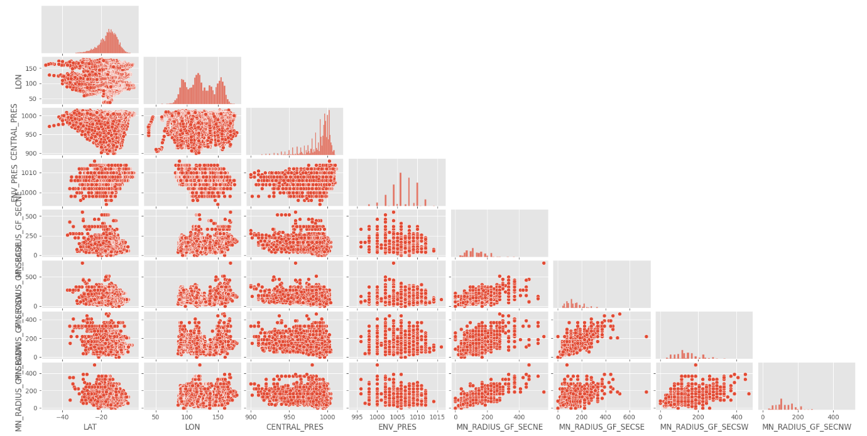

Figure 7 - Scatter Plots of all variables for all cyclones used in modelling after cleaning Longitude data